**PEMROGRAMAN MOBILE**

**Dosen Pengampu : I Ketut Resika Arthana,ST.,M.Kom.**

**Tugas BMI**



**OLEH :**

**I GEDE KEMBAR ARTHAYASA**

**PTI 4B**

**1815051091**

**PRODI PENDIDIKAN TEKNIK INFORMATIKA**

**JURUSAN TEKNIK INFORMATIKA**

**FAKULTAS TEKNIK DAN KEJURUAN**

**UNIVERSITAS PENDIDIKAN GANESHA**

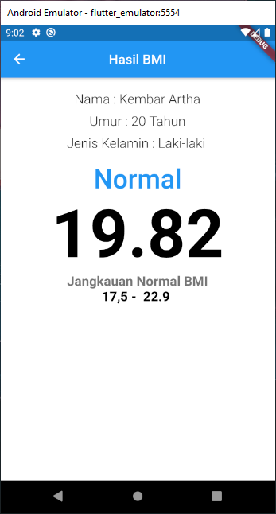

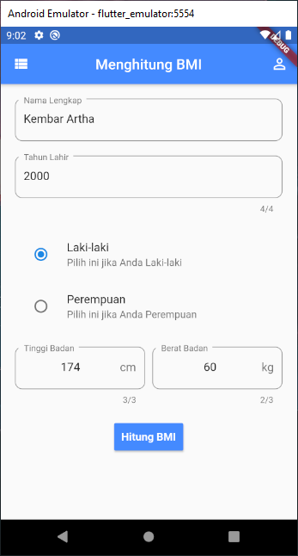

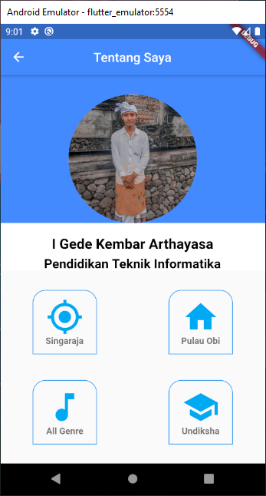

about_me.dart

import 'package:flutter/cupertino.dart';  
import 'package:flutter/material.dart';  
  
class MyProfil extends StatelessWidget {  
 @override  
 Widget build(BuildContext context) {  
 return  
 new Scaffold(  
 appBar: AppBar(  
 backgroundColor: Colors.*blueAccent*,  
 title: Text("Tentang Saya"),  
 centerTitle: true,  
 ),  
 body: ListView(  
 children: <Widget>[  
 Container(  
 color: Colors.*blueAccent*,  
 child: Stack(  
 children: <Widget>[  
 Padding(  
 padding: EdgeInsets.only(top: 30),  
 child: Align(  
 alignment: Alignment.*topCenter*,  
 child: Container(  
 height: 200,  
 width: 200,  
 decoration: BoxDecoration(  
 borderRadius: BorderRadius.circular(100),  
 image: DecorationImage(image: AssetImage('img/kembar.PNG'),  
 fit: BoxFit.cover  
 )  
 ),  
 ),  
 ),  
 ),  
 ],  
 ),  
 ),  
  
 Container(  
 color: Colors.*white*,  
 child: Column(  
  
 children: <Widget>[  
 SizedBox(height: 20),  
 Text('I Gede Kembar Arthayasa',  
 style: TextStyle(  
 fontWeight: FontWeight.*bold*,  
 fontSize: 22,  
 color: Colors.*black*,  
 ),  
 ),  
 SizedBox(height: 5,child: Container(  
 color: Colors.*white*,  
 ),),  
 Row(  
 mainAxisAlignment: MainAxisAlignment.center,  
 children: <Widget>[  
 Text('Pendidikan Teknik Informatika',  
 style: TextStyle(  
 fontWeight: FontWeight.*bold*,  
 fontSize: 20,  
 color: Colors.*black* ),  
 )  
  
 ],  
 ),  
 ],  
 ),  
 ),  
 Container(  
 padding: EdgeInsets.only(top: 30, right: 50, left: 50),  
 child: Column(  
 children: <Widget>[  
 Padding(  
 padding: const EdgeInsets.all(0),  
 child: Row(  
 mainAxisAlignment: MainAxisAlignment.spaceBetween,  
 children: <Widget>[  
 Container(  
 height: 100,  
 width: 100,  
 decoration: BoxDecoration(  
 border: Border.all(color: Colors.*blue*),  
 //color: Colors.green,  
 borderRadius: BorderRadius.only(topRight: Radius.circular(20), topLeft: Radius.circular(20)),  
  
 ),  
  
 child: Padding(  
 padding: const EdgeInsets.all(12.0),  
 child: Column(  
 children: <Widget>[  
 Icon(Icons.*my_location*,  
 color: Colors.*lightBlue*,  
 size: 58),  
 Text('Singaraja',  
 style: TextStyle  
 (color: Colors.*black54*,  
 fontWeight: FontWeight.*bold* ), )  
 ],  
 ),  
 ),  
 ),  
  
 Container(  
 height: 100,  
 width: 100,  
 decoration: BoxDecoration(  
 border: Border.all(color: Colors.*blue*),  
 //color: Colors.green,  
 borderRadius: BorderRadius.only(topRight: Radius.circular(20), topLeft: Radius.circular(20)),  
 ),  
  
 child: Padding(  
 padding: const EdgeInsets.all(12.0),  
 child: Column(  
 children: <Widget>[  
 Icon(Icons.*home*, color: Colors.*lightBlue*, size: 58,),  
 Text('Pulau Obi', style: TextStyle  
 (color: Colors.*black54*,  
 fontWeight: FontWeight.*bold* ),  
 ),  
 ],  
 ),  
 ),  
 ),  
  
 ],  
 ),  
 ),  
 Padding(  
 padding: const EdgeInsets.only(top: 40),  
 child: Row(  
 mainAxisAlignment: MainAxisAlignment.spaceBetween,  
 children: <Widget>[  
 Container(  
  
 height: 100,  
 width: 100,  
 decoration: BoxDecoration(  
 border: Border.all(color: Colors.*blue*),  
 //color: Colors.green ,  
 borderRadius: BorderRadius.only(topRight: Radius.circular(20), topLeft: Radius.circular(20)),  
  
  
 ),  
  
 child: Padding(  
 padding: const EdgeInsets.all(12.0),  
 child: Column(  
 children: <Widget>[  
 Icon(Icons.*music_note*,color: Colors.*lightBlue*, size: 58,),  
 Text('All Genre', style: TextStyle  
 (color: Colors.*black54*,  
 fontWeight: FontWeight.*bold* ),  
 ),  
 ],  
 ),  
 ),  
 ),  
 Container(  
  
 height: 100,  
 width: 100,  
 decoration: BoxDecoration(  
 border: Border.all(color: Colors.*blue*),  
 borderRadius: BorderRadius.only(topRight: Radius.circular(20), topLeft: Radius.circular(20)),  
 ),  
  
 child: Padding(  
 padding: const EdgeInsets.all(12.0),  
 child: Column(  
 children: <Widget>[  
 Icon(Icons.*school*, color: Colors.*lightBlue* , size: 58,),  
 Text('Undiksha',style: TextStyle  
 (color: Colors.*black54*,  
 fontWeight: FontWeight.*bold* ),  
 ),  
 ],  
 ),  
 ),  
 )  
 ],  
 ),  
 )  
 ],  
 ),  
 )  
 ],  
 ),  
 );  
 }  
}

bmi.dart

import 'package:flutter/material.dart';  
import 'package:flutter/rendering.dart';  
import 'bmi_result.dart';  
  
class InputBMI extends StatefulWidget {  
 @override  
 _InputBMIState createState() => _InputBMIState();  
}  
  
class _InputBMIState extends State<InputBMI> {  
 int tinggi = 0;  
 int berat = 0;  
  
 @override  
 Widget build(BuildContext context) {  
 return  
 Scaffold(  
 //backgroundColor: Colors.blue[50],  
 appBar: AppBar(  
 //backgroundColor: Colors.blue[900],  
 centerTitle: true,  
 leading: Icon(  
 Icons.*favorite*,  
 color: Colors.*pink*,  
 ),  
 title: Text('MENGHITUNG BMI'),  
 ),  
 body: SingleChildScrollView(  
 child: Column(  
 crossAxisAlignment: CrossAxisAlignment.stretch,  
 mainAxisAlignment: MainAxisAlignment.start,  
 children: <Widget>[  
 Container(  
 child:  
 Image.asset('images/bmi.jpg',  
 fit: BoxFit.fitWidth,  
 ),  
 ),  
  
 Container(  
 margin: EdgeInsets.only(top: 20),  
 padding: EdgeInsets.all(10),  
 // color: Colors.blue[700],  
 child: Row(  
 children: <Widget>[  
 Expanded(  
 child: TextField(  
 onChanged: (txt) {  
 setState(() {  
 tinggi = int.*parse*(txt);  
 });  
 },  
 keyboardType: TextInputType.*number*,  
 maxLength: 3,  
 textAlign: TextAlign.center,  
 style: TextStyle(  
 fontSize: 20,  
 ),  
 decoration: InputDecoration(  
 suffix: Text('cm'),  
  
 filled: true,  
 hintText: 'Tinggi'),  
 ),  
 ),  
 SizedBox(  
 width: 10,  
 ),  
 Expanded(  
 child: TextField(  
 onChanged: (txt) {  
 setState(() {  
 berat = int.*parse*(txt);  
 });  
 },  
 keyboardType: TextInputType.*number*,  
 maxLength: 3,  
 textAlign: TextAlign.center,  
 style: TextStyle(  
 fontSize: 20,  
 ),  
 decoration: InputDecoration(  
 suffix: Text('kg'),  
 filled: true,  
 hintText: 'Berat'),  
 ),  
 ),  
 ],  
 )),  
  
 Container(  
 //height: double.infinity,  
 margin: EdgeInsets.only(left: 10,right: 10,bottom: 20),  
 child: RaisedButton(  
 onPressed: () {  
 Navigator.*push*(  
 context,  
 MaterialPageRoute(builder: (context) => BMIResult(tinggi_badan: tinggi, berat_badan: berat)),  
 );  
 },  
 padding: EdgeInsets.only(top: 10, bottom: 10),  
 color: Colors.*black*,  
 // textColor: Colors.white,  
 child: Text(  
 'HITUNG BMI',  
 style:  
 TextStyle(fontSize: 30, fontWeight: FontWeight.*w500*),  
 ),  
 ),  
 ),  
  
  
  
 ],  
 ),  
 ),  
 bottomNavigationBar: BottomAppBar(  
 //color: Colors.transparent,  
 child: Container(  
 height: 60,  
 color: Colors.*black54*,  
 alignment: Alignment.*center*,  
 child: Text(  
 'Developed by Resika Arthana',  
 style: TextStyle(  
 fontSize: 20,  
 fontWeight: FontWeight.*w500*,  
 color: Colors.*white*),  
 ),  
 ),  
 //elevation: 0,  
 ),  
 );  
 }  
}

bmi_result.dart

import 'package:flutter/material.dart';  
import 'dart:math';  
import 'about_me.dart';  
  
class BMIResult extends StatelessWidget {  
  
  
 BMIResult({@required this.tinggi_badan, @required this.berat_badan, @required this.nama_lengkap, @required this.tahun_lahir, @required this.jk});  
 final int tinggi_badan;  
 final int tahun_lahir;  
 final int berat_badan;  
 final String nama_lengkap;  
 final String jk;  
  
  
  
 @override  
 Widget build(BuildContext context) {  
 double bmi = berat_badan/pow(tinggi_badan/100,2);  
 String cBMI;  
 if (bmi>=28) cBMI="Obesitas";  
 else if (bmi>=23) cBMI="Gemuk";  
 else if (bmi>=17.5) cBMI="Normal";  
 else cBMI="Kurus";  
  
  
 return Scaffold(  
 appBar: AppBar(  
 centerTitle: true,  
 title: Text('Hasil BMI'),  
 ),  
 body: Container(  
 color: Colors.*white*,  
 alignment: Alignment.*center*,  
 child: Column(  
 mainAxisAlignment: MainAxisAlignment.start,  
 crossAxisAlignment: CrossAxisAlignment.center,  
 children: <Widget>[  
 SizedBox(height: 20,child: Container(  
 color: Colors.*white*,  
 ),),  
 new Text(  
 "Nama : ${nama_lengkap}",  
 style: TextStyle(  
 fontSize: 20,  
 fontWeight: FontWeight.*w300*,  
 color: Colors.*black87* ),  
 ),  
 SizedBox(height: 10,child: Container(  
 color: Colors.*white*,  
 ),),  
 new Text(  
 "Umur : ${2020 - tahun_lahir} Tahun",  
 style: TextStyle(  
 fontSize: 20,  
 fontWeight: FontWeight.*w300*,  
 color: Colors.*black87* ),  
 ),  
 SizedBox(height: 10,child: Container(  
 color: Colors.*white*,  
 ),),  
 new Text(  
 "Jenis Kelamin : ${jk} ",  
 style: TextStyle(  
 fontSize: 20,  
 fontWeight: FontWeight.*w300*,  
 color: Colors.*black87* ),  
 ),  
 SizedBox(height: 20,child: Container(  
 color: Colors.*white*,  
 ),),  
 Text(  
 cBMI,  
 style: TextStyle(  
 fontSize: 40,  
 fontWeight: FontWeight.*w500*,  
 color: Colors.*blue*,  
 ),  
 ),  
 Text(  
 bmi.toStringAsFixed(2),  
 style: TextStyle(  
 fontSize: 100,  
 fontWeight: FontWeight.*w800*,  
 color: Colors.*black*,  
 ),  
 ),  
  
  
 Text(  
 'Jangkauan Normal BMI',  
 style: TextStyle(  
 fontSize: 20,  
 fontWeight: FontWeight.*w800*,  
 color: Colors.*black54*,  
 ),  
 ),  
 Text(  
 '17,5 - 22.9 ',  
 style: TextStyle(  
 fontSize: 20,  
 fontWeight: FontWeight.*w800*,  
 color: Colors.*black*,  
 ),  
 ),  
  
 ],  
 ),  
 ),  
 );  
 }  
}

main.dart

//import 'dart:html';  
  
import 'package:flutter/material.dart';  
import 'bmi_result.dart';  
import 'about_me.dart';  
  
void main(){  
 runApp(new MaterialApp(  
 home: new Home(),  
 routes: <String, WidgetBuilder>{  
 '/Halsatu' : (BuildContext context) => new Home(),  
 '/Haldua' : (BuildContext context) => new MyProfil(),  
  
 },  
 ));  
}  
  
class Home extends StatefulWidget {  
 @override  
 _HomeState createState() => new _HomeState();  
}  
  
class _HomeState extends State<Home> {  
  
 int tinggi = 0;  
 int berat = 0;  
 int tahun = 0;  
  
 String _jk="";  
  
 void _pilihJk(String value){  
 setState(() {  
 _jk = value;  
 });  
 }  
  
 var _nama = new TextEditingController();  
  
 @override  
 Widget build(BuildContext context) {  
 return new Scaffold(  
 appBar: new AppBar(  
 leading: new Icon(Icons.*view_list*),  
 title: new Text('Menghitung BMI'),  
 centerTitle: true,  
 backgroundColor: Colors.*blueAccent*,  
 actions: <Widget>[  
 new IconButton(  
 icon: Icon(Icons.*person_outline*),  
 onPressed: (){  
 Navigator.*pushNamed*(context, '/Haldua');  
 },  
 )  
 ],  
 ),  
  
 body: ListView(  
 children: <Widget>[  
 new Container(  
 padding: new EdgeInsets.all(20.0),  
 child: new Column(  
 children: <Widget>[  
 new TextField(  
 controller: _nama,  
 decoration: new InputDecoration(  
 hintText: "Masukkan Nama Lengkap",  
 labelText: "Nama Lengkap",  
 border: new OutlineInputBorder(  
 borderRadius: new BorderRadius.circular(10.0)  
 )  
 ),  
 ),  
  
 new Padding(padding: new EdgeInsets.only(top: 20.0)),  
  
 new TextField(  
 onChanged: (txt) {  
 setState(() {  
 tahun = int.*parse*(txt);  
 });  
 },  
  
 keyboardType: TextInputType.*number*,  
 maxLength: 4,  
 decoration: new InputDecoration(  
 hintText: "Masukkan Tahun Lahir",  
 labelText: "Tahun Lahir",  
 border: new OutlineInputBorder(  
 borderRadius: new BorderRadius.circular(10.0)  
 )  
 ),  
 ),  
 new Padding(padding: new EdgeInsets.only(top: 20.0)),  
  
 new RadioListTile(  
 value: "Laki-laki",  
 groupValue: _jk,  
 title: new Text("Laki-laki"),  
 onChanged: (String value){  
 _pilihJk(value);  
 },  
 subtitle: new Text("Pilih ini jika Anda Laki-laki"),  
 ),  
 new Padding(padding: new EdgeInsets.only(top: 0.0)),  
 new RadioListTile(  
 value: "Perempuan",  
 groupValue: _jk,  
 title: new Text("Perempuan"),  
 onChanged: (String value){  
 _pilihJk(value);  
 },  
 subtitle: new Text("Pilih ini jika Anda Perempuan"),  
 ),  
  
 new Padding(padding: new EdgeInsets.only(top: 20.0)),  
  
 new Row(  
 children: <Widget>[  
 Expanded(  
 child: TextField(  
 onChanged: (txt) {  
 setState(() {  
 tinggi = int.*parse*(txt);  
 });  
 },  
  
 keyboardType: TextInputType.*number*,  
 maxLength: 3,  
 textAlign: TextAlign.center,  
 style: TextStyle(  
 fontSize: 16,  
 ),  
 decoration: InputDecoration(  
 labelText: "Tinggi Badan",  
 suffix: Text('cm'),  
 border: new OutlineInputBorder(  
 borderRadius: new BorderRadius.circular(10.0)  
 ),  
 //filled: true,  
 hintText: 'Tinggi'),  
 ),  
 ),  
 SizedBox(  
 width: 10,  
 ),  
 Expanded(  
 child: TextField(  
  
 onChanged: (txt) {  
 setState(() {  
 berat = int.*parse*(txt);  
 });  
 },  
  
 keyboardType: TextInputType.*number*,  
 maxLength: 3,  
 textAlign: TextAlign.center,  
 style: TextStyle(  
 fontSize: 16,  
 ),  
 decoration: InputDecoration(  
 labelText: "Berat Badan",  
 suffix: Text('kg'),  
 border: new OutlineInputBorder(  
 borderRadius: new BorderRadius.circular(10.0)  
 ),  
 //filled: true,  
 hintText: 'Berat'),  
  
 ),  
 ),  
 ],  
 ),  
  
 new Padding(padding: new EdgeInsets.only(top: 20.0)),  
  
  
 Container(  
 //height: double.infinity,  
 margin: EdgeInsets.only(left: 10,right: 10,bottom: 20),  
 child: RaisedButton(  
 onPressed: () {  
 var route = new MaterialPageRoute(  
 builder: (BuildContext) =>  
 new BMIResult(nama_lengkap : _nama.text,tinggi_badan: tinggi, berat_badan: berat, tahun_lahir: tahun, jk: _jk),  
 );  
 Navigator.*of*(context).push(route);  
 /*  
 Navigator.push(  
 context,  
 MaterialPageRoute(builder: (context) => BMIResult(tinggi_badan: tinggi, berat_badan: berat)),  
 );  
 */  
 },  
 padding: EdgeInsets.all(10.0),  
 color: Colors.*blueAccent*,  
 textColor: Colors.*white*,  
 child: Text(  
 'Hitung BMI',  
 style:  
 TextStyle(fontSize: 15, fontWeight: FontWeight.*bold*),  
  
 ),  
 ),  
 ),  
 ],  
 ),  
 ),  
 ],  
 ),  
 );  
 }  
}